07 — Wireshark Traffic Capture Practical
Network Traffic Analysis, Nmap and Windows Logging

Objective
Capture and interpret TCP connection establishment, HTTP requests, DNS queries and ICMP echo traffic between lab virtual machines.

Lab environment
- Kali Linux: 192.168.56.102 (traffic generation and analysis).
- Ubuntu: 192.168.56.101 (Apache HTTP server).
- Windows 11: 192.168.56.104 (used elsewhere in Week 2).
- Host-only VirtualBox network: 192.168.56.0/24.

Method
- Install Apache on Ubuntu with sudo apt install apache2.
- Capture traffic on the relevant interface in Wireshark.
- From Kali, generate ICMP echo requests with ping and an HTTP request with curl.
- Generate a DNS lookup with nslookup; note that DNS may query a configured DNS server rather than the Ubuntu web server.
- Apply Wireshark display filters to isolate the relevant packet sequences.

Packet analysis — TCP handshake
A TCP connection normally begins with SYN, SYN/ACK and ACK. These packets establish a connection before application data is exchanged. The screenshot in the archive is used as evidence of the observed sequence.

Packet analysis — HTTP
HTTP GET requests retrieve a resource from a web server. HTTP without TLS is readable in packet captures; analysts can inspect method, host and path where present.

Packet analysis — DNS
DNS queries resolve names into addresses. Analysts inspect query names, response codes and unusual query patterns; a DNS query is not suspicious on its own.

Packet analysis — ICMP
ICMP echo requests and replies support connectivity tests. Analysts consider unusual volume or patterns when investigating scanning or tunnelling.

Capture artifacts
PCAPNG files in Captures/PCAP: ICMP_HTTP_TCP_Traffic.pcapng, DNS_Traffic.pcapng and Nmap_SYN_RST_Capture.pcapng. The third file relates to the separate Nmap practical.

SOC relevance and conclusion
The exercise develops a baseline understanding of ordinary protocol behaviour and makes scan-related traffic easier to recognize in later IDS/Snort exercises. Packet-level interpretations should always be checked against the actual capture and context.

Evidence
TCP three-way handshake screenshot
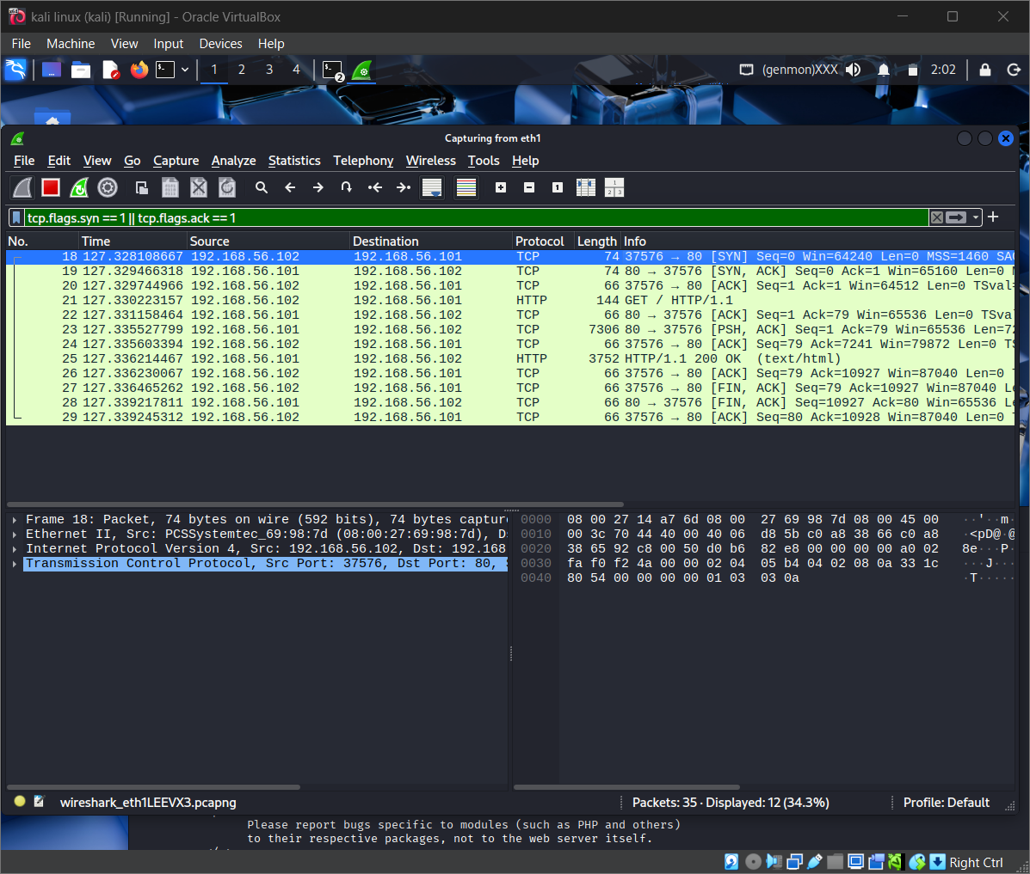
HTTP GET screenshot
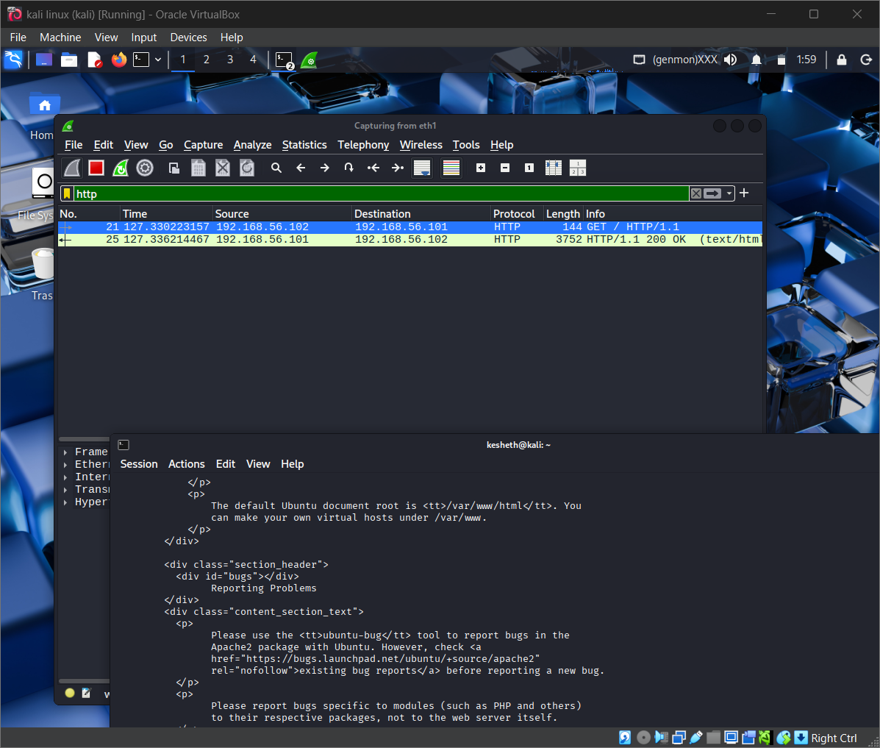
DNS query screenshot
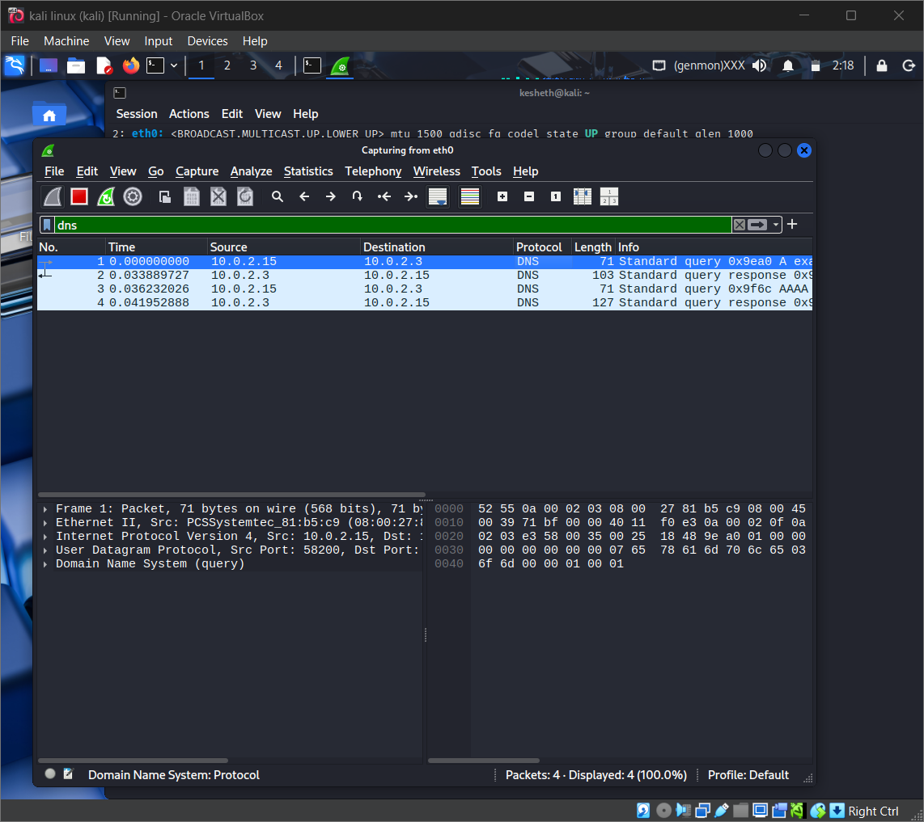
ICMP echo screenshot
